A Resource Website for Climate Change Impacts on Health and Population in Bangladesh: Completion Report

Peter Kim Streatfield
Mahin Al Nahian
Tanvir Ahmad
Suhan Ahmed
Mithun Dutta
Sifatur Rahman

March 2023

Table of Contents

Introduction 2
Rationale and Motivation 2
Activity Objective 2
Technical specifications of the website 3
Website Contents 3
Knowledge Briefs 4
a. Lightning: Death from Above 4
b. Air Pollution: The Invisible Killer 4
c. Heatwaves: The Silent Killer 4
d. Temperature Trends in Bangladesh 4
e. An Overview on Climate Change and Health 4
Dissemination Activities 4
a. Dissemination session on a resource website for climate change and health 4
b. Storytelling Session with the Journalists 6
c. Media Mapping 6
d. Sustainability of the website and way forward 7

Introduction
Bangladesh, a country that is severely exposed to the impacts of climate change and natural disasters and was continuously in the rank of top vulnerable countries in the Global Climate Risk Index, health adaptation is a critical development and sustainability concern. In order to monitor the growing impacts of climate change on health in Bangladesh, requires a variety of scattered and sometimes obscure data sources, on climate change, health, and population outcomes. In order to address this information gaps and sensitization of policy makers and health stakeholders with general knowledge on climate change impacts on health, a single web-based platform has been established by the Initiative of Climate Change and Health (ICCH) of icddr,b. The website “https://cch.icddrb.org” has been developed under the USAID funded Research for Decision Makers (RDM) Activity.

Rationale and Motivation
The monitoring of the expanding implications of climate change (CC) on health in Bangladesh requires a variety of data sources on CC, health, and population outcomes. These data sources can often be hard to find. Because of the dispersed nature of the information pertaining to this subject, there is a pressing need to compile all of the relevant aspects into a single website. This website should offer sources of pertinent data, scientific publications, and concise explanations of the science of climate change and its influence on health.
We anticipate that this website, referred to as "cch.icddrb.org," would be of great use to scholars and practitioners in Bangladesh who work at the intersection of climate change and health. This should provide academics, program managers, and policymakers with vital data and discussion to enable them to evaluate and monitor climate change's impact on health and devise actions that may reduce such negative consequences.

Activity Objective
The primary objective is to bring together data sources and links related to climate change and health in a single web-based location.
Additional objectives
- Knowledge briefs on specific topics related to climate change and health, based on the information available on the website.
- Development of composite vulnerability maps for existing health facilities and systems in coastal areas against multiple types of climatic stressors.

Technical specifications of the website
The website has cross-browser compatibility, and a user-friendly interface, custom illustrations, soft shadows, layers, floating elements, and other modern design techniques are used. The website's design is fully responsive so that mobile users can get the most out of it. The developer company followed all the rules set by the World Wide Web Consortium (W3C) and the Web Content Accessibility Guidelines (WCAG).
The website has been designed to be lightweight, and the company has ensured faster load performance for improved user experiences. The Open Web Application Security Project (OWASP) standards are followed to ensure that the website is free from any vulnerabilities, threats, or risks. The contents of the website are visualized and presented in interactive ways. To manage all contents, a separate user-friendly content management system is provided. Admin users are able to create, publish, and delete contents. Both the admin and the users can sort, search, and download the data, which can be turned on or off for the users.

Website Contents
On this website, important information pertaining to climate change is presented. Some of the topics covered on this website include climate change-related threats like vector-borne diseases like dengue, malaria, kala-azar, and chikungunya; heat waves and heat stress; air pollution and related conditions like hypertension; cardiovascular diseases; respiratory infections; water pollution and water-borne diseases like cholera; climate change-related food security issues and associated malnutrition threats; and so on. Information on climatic disasters such as cyclones, floods, and droughts, as well as local and global climate change-related factors such as the rise in sea level, salinity, sea surface temperature, carbon dioxide (CO₂) trend, global temperature trends, global greenhouse gas levels, El Nino/La Nina, and the Indian Ocean Dipole has also been included in the website.
The information featured on this website addresses global and local climate concerns and provides relevant facts. The website also integrates and delivers real-time statistics and interactive graphs on climate factors such as hourly, daily, and monthly temperature, humidity, and air pollution (Air Quality Index, PM2.5) recorded by an "IQAir device." The real time data of temperature, humidity and air quality index (AQI) covers a radius of 1.5-2.0 km around Mohakhali, Dhaka. Also, the website features graphs that are both interactive and dynamic, and they are based on the climatic parameters that have been gathered from the Bangladesh Meteorological Department (BMD).

Knowledge Briefs
A series of briefing papers related to the website's material with some of the most significant events due to climate change were also developed. The flowing list contains the title of the knowledge briefs, available at: https://cch.icddrb.org/knowledge-briefs

a. Lightning: Death from Above

b. Air Pollution: The Invisible Killer

c. Heatwaves: The Silent Killer

d. Temperature Trends in Bangladesh

e. An Overview on Climate Change and Health
Composite vulnerability maps for the health systems in coastal Bangladesh
Under the objective, the team first prepared informative maps on the Coastal Zone of Bangladesh, that was approved by the 6th Inter-Ministerial Technical Committee, which selected 19 districts and 147 upazilas as the coastal zone of Bangladesh on October 25, 2003. In second step, based on the INFORM framework, that assesses the risk of coastal communities, considering socioeconomic vulnerabilities and vulnerable groups as well as institutional and infrastructural coping capacity under multiple natural hazards, multiple coastal zone maps has been prepared on ‘hazards and exposure, ’ ‘vulnerability,’ and ‘lack of coping capacity.’ After integrating the 3 maps, a composite risk map for health facilities in coastal Bangladesh has been developed.

Dissemination Activities

a. Dissemination session on a resource website for climate change and health
On February 13, 2023, the dissemination event of the website was completed at icddr,b. Dr. Streatfield and Mr. Ahsan, displayed the features and operation of the website. The event was attended by representatives from the Ministry of Health and Family Welfare (MoHFW) and Ministry of Environment, Forest, and Climate Change (MoEFCC), the Government of Bangladesh, USAID, icddr,b, and other development partners. The dissemination session was organized by the support of RDM activity of USAID, Bangladesh.

A view of the dissemination event
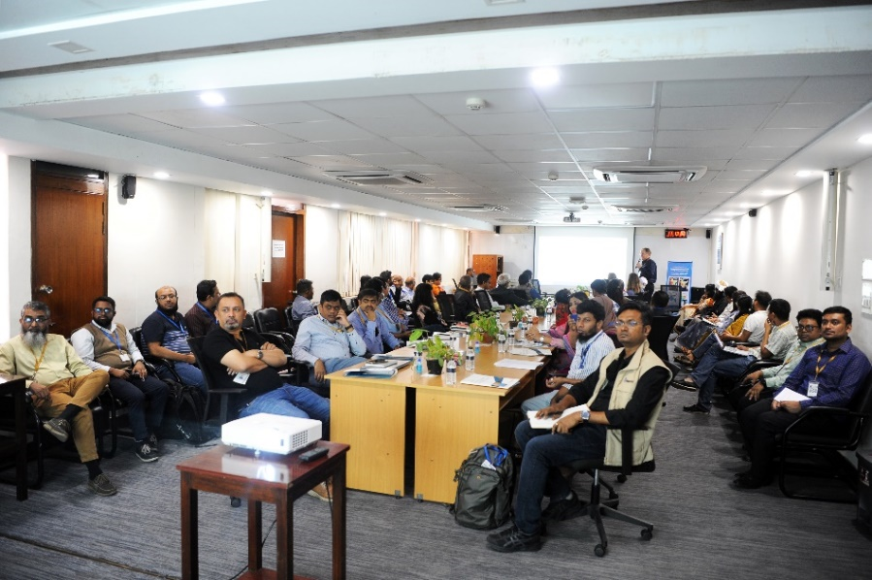

Dr Streatfield in his presentation on the climate change and health issue in Bangladesh and the importance of the CCH website in monitoring such impacts (left).

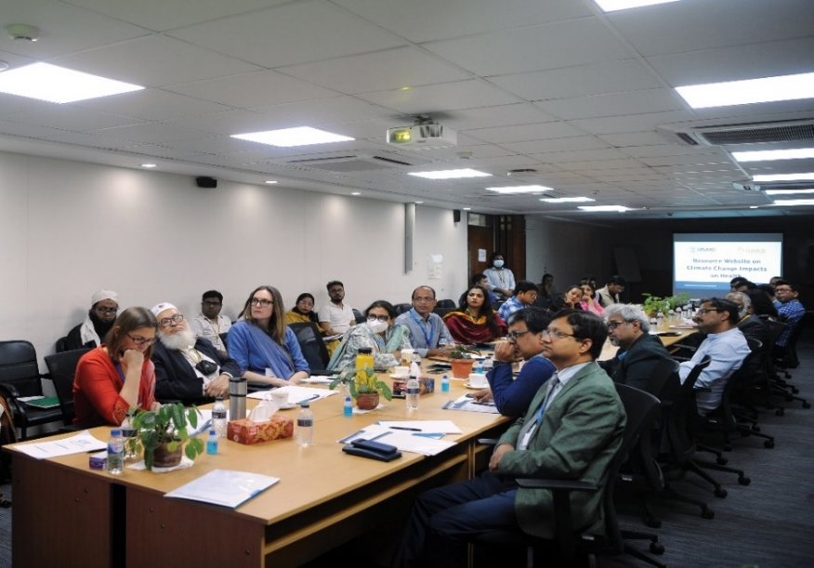

Distinguished guests and audience listening the presentation (right).
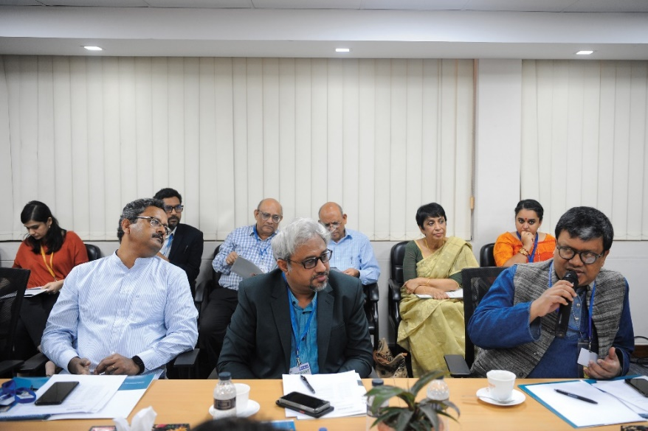

Open discussion followed by the website demonstration (left).

b. Storytelling Session with the Journalists
On February 28, 2023, the website was introduced to journalists from different print and broadcast media. Dr. Streatfield and Mr. Ahmad presents the website in front of the journalist. The storytelling session was organized by D4I activity of USAID.

c. Media Mapping
The news of the climate change and health resources website grabbed quite good media attention. So far, 32 media houses covered the event and website information with follow-up news articles with previously RDM supported research study on air pollution and negative birth outcomes.
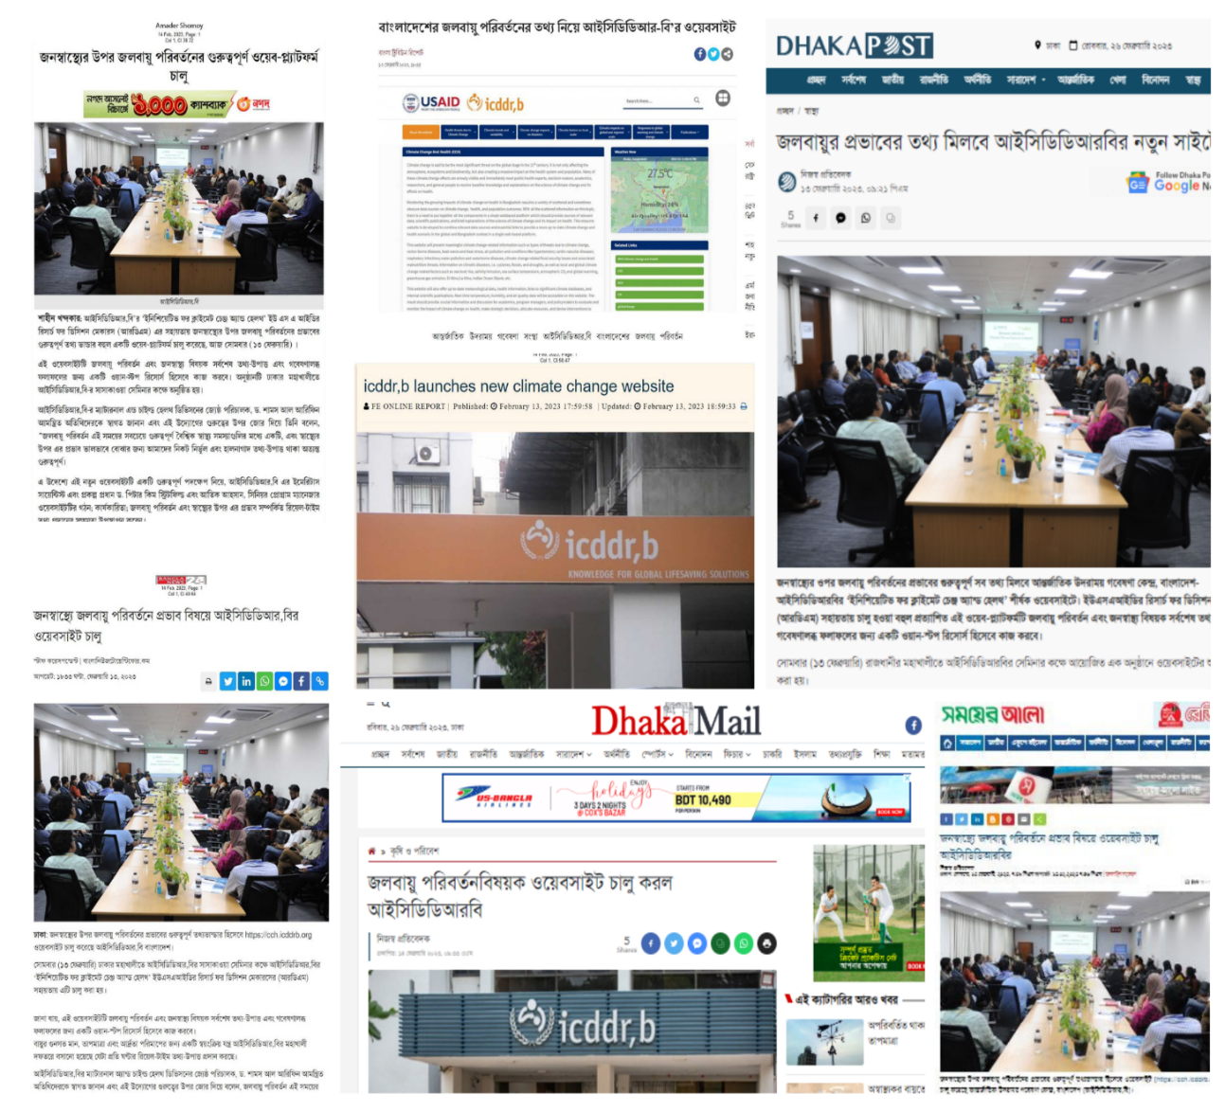

d. Sustainability of the website and way forward
The ‘climate change and health resources website’ should continue to help researchers and practitioners in Bangladesh who work at the intersection of climate change and health. The content and materials on the website will be updated regularly by the research team. The website is already providing information on air quality, temperature and humidity for the icddr,b/ Mohakhali area to be used for research purpose. The team has planned to integrate more robust weather data in the website by procuring a weather station; in order to minimize dependency on BMD data (which is only assessible after one year without much practical usability) and generate specific health warnings based on day-to-day weather data. For this, the team is developing proposals and applying to different grant calls in order to utilize the website in a more practical way. The website content and materials are also being utilized to develop different concept notes. Students and young researchers are assessing the website for climate change and health specific information and expressing their interest to do internship with the research team.
The website is being hosted in the icddr,b server. After the RDM project comes to an end, the website will be continued to be managed by the research team. The operation and management expense of the website will be borne by icddr,b. icddr,b believes this website is an important asset and thus, will ensure the sustainability of the website in the best possible way.

Disclaimer:
This report is produced with the support of the United States Agency for International Development (USAID) under the terms of USAID’s Research for Decision Makers (RDM) Activity cooperative agreement no. AID-388-A-17-00006. Views expressed herein do not necessarily reflect the views of the U.S. Government or USAID.
To visit the website:

